Interview with Iiris Björnberg

Finland receiving private lessons in Augsburg (Germany)
How the prevention program Papilio is helping Pisa’s frontrunner

Augsburg, February 2nd 2016. Nowadays, it is the Germans who enviously look at Finland regarding educational issues; the pupils from that Scandinavian country regularly surpass the Germans in Pisa (Program for International Student Assessment) studies. Even after bringing the Augsburg-based prevention program Papilio into their country to strengthen the socio-emotional competencies of kindergartners, the Finns are now receiving additional training in Germany. We spoke to the programme’s initiator Iiris Björnberg about the shortcomings of the Finnish educational system and the opportunities Papilio offers to its children.

Mrs Björnberg, Why has Pisa’s frontrunner Finland come to Germany for assistance on educational issues?

Björnberg: You have to see it more widely. We Finns are actually among the best in the Pisa study. Our schools are excellent and knowledge is imparted efficiently, but that is only one aspect of education; there are also several studies that have shed light on shortcomings. For example, only a few children really enjoy going to school; every tenth teenager even suffers from it. And many Finnish children have no friends, nor do they cultivate any social contacts.

Do you mean to say that Finland’s schools primarily impart knowledge at the expense of social and emotional concerns? Is that the reason for your interest in Papilio?

Björnberg: Yes, exactly. We perform well in Pisa tests, but we seem incapable of being able to discuss emotions, and that may have serious consequences.

What kinds of consequences?

Björnberg: Substance abuse and violence are growing problems among our youth. Addictive behaviour is often the only solution when negative emotions are being ignored, and may even lead to violence. Time after time our teenagers also stand out in different studies because of high suicide rates and continuous bouts of depression.

How can Papilio help here?

Björnberg: Papilio helps kindergartners identify their emotions at an early age. ‘Am I sad? Am I angry or happy? Am I afraid?’ They also learn to talk about it and recognise the emotional states of others – this has never been one of Finland’s strongest cultural traits. Papilio also promotes conflict resolution without violence, resulting in better empathy and a greater sense of community. The children are thus already strengthened for later life at a very early stage, making them less susceptible to addictive or violent behaviour. All this has been scientifically proven.

You started Papilio in two Finnish kindergartens in June. Since then the programme has been implemented at three more kindergartens. What are your first impressions?

Björnberg: The kindergarten teachers receiving Papilio training during the pilot phase are highly committed. Naturally they had already been encouraging the children’s socio-emotional competencies in their daily work prior to that. But it is only now that they have the use of concrete tools that facilitate more systematic work. This inspires the kindergarten teachers.

Even the Finnish Ministry of Education and Culture supports the implementation of the Papilio program. How did you convince the government to adopt an approach formulated in Augsburg?

Björnberg: The effectiveness of the program has been proven scientifically. Advocates at Finnish universities confirmed the experts’ findings and have campaigned on behalf of Papilio. The universities in Jyväskylä and Turku now augment the programme’s implementation with scientific surveys.

You began implementing Papilio in Finland in June. Now there are four qualified trainers. 89 kindergarten teachers in five kindergartens have already been trained; about 450 children are benefitting from Papilio. How will this now continue?

Björnberg: We are currently developing the organisational processes that will bring Papilio to other kindergartens. The universities’ surveys are also progressing simultaneously. We expect to see the first results in the summer of 2016. Afterwards, we will adjust the program to fit Finland’s special conditions if necessary. The ultimate aim will be to provide Papilio in day-care centres nationwide.

In Germany, the program also thrives on the close collaboration among kindergarten teachers, children, and parents. The parents’ club is an integral part of Papilio. Is it the same in Finland?

Björnberg: We are already developing the parents’ club format; naturally it is the involvement of the parents that makes the program so effective. We also want to have this in Finland.

And what about the pixies in the box, that are touring Germany with the Augsburger Puppenkiste? Will they soon be touring Finland as well?

Björnberg: We’ll see. The Papilio material and songs are already available in Finnish. And we have also invited the pixies in the box. Maybe they will be coming to visit us soon. We would appreciate it and it would be fun!

Pictures:
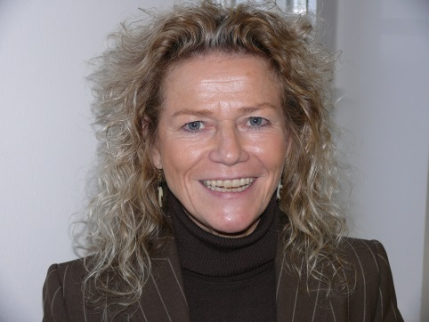
Iiris Björnberg also sees many shortcomings in the respected Finnish educational system. “Papilio may provide assistance,” she says.
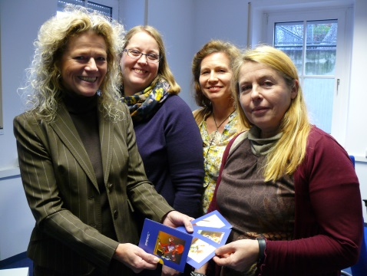
After bringing Papilio to Finland, Iiris Björnberg (left) was in Augsburg for further training with Merja Koivula, Ursula Nystedt-Rintakumpu, and Marita Neitola (left-to-right).

Further information:
Papilio e.V.
Annika Jungclaus, Tel. +49 (0)821 4480 3297, E-mail: annika.jungclaus@papilio.de
Andrea Finkel, Tel. +49 (0)821 24 26 302-23, E-mail: medien@papilio.de
Press and Public Relations: www.papilio.de

Papilio e.V.
www.papilio.de
Chairman of the Board: Heidrun Mayer
Ulmer Str.94, 86156 Augsburg, Germany, District Court of Augsburg Register of Associations VR 200829

About Papilio:
The social enterprise Papilio e.V. offers a programme aimed at the early prevention of addictive and violent behaviour. Specifically developed for young children, the programme has been well received in many countries and its effectiveness has been scientifically proven. It includes kindergarten teachers, children, and parents. Children playfully learn social rules as well as how to interact with each other and resolve conflicts non-violently. All in all, Papilio reduces early behavioural problems, encourages socio-emotional competency, and provides children with the necessary skills that will make them less susceptible to the development of addictive and violent behaviour in later life. In Germany, Papilio has been introduced in 12 federal states and more than 6,000 educational professionals – reaching more than 123,000 children nationwide – have been trained in the programme. For further information visit: www.papilio.de

