Press release

Papilio helping Finnish children
Prevention program from Augsburg/Germany also proliferating in Scandinavia

Augsburg, February 2nd 2016. Since June 2015, the German prevention program Papilio has also been available in Finland. Only six months after its introduction, approximately 450 children at five day-care centres are already profiting from a concept that verifiably strengthens kindergartners’ socio-emotional competencies. The implementation continues; three additional Finnish Papilio trainers have been qualified at Papilio’s headquarters in Augsburg. In the coming years, Heidrun Mayer, the first chairwomen of Papilio e.V., and Iiris Björnberg, the initiator of the Finnish project, are planning to introduce the concept to Finland, where the Ministry of Education and Culture will support the practical implementation of Papilio in Finland. Thanks to a donation by Ilari Schouwvlieger to the Lapset Ensin (“Children First”) association funding the project, the translation work required for the importation of Papilio to Finland could begin.

It is already clear that Papilio, whose implementation has been encouraged by the Finnish Ministry of Education and Culture, has been well received in Finland, and the first experiences have been consistently positive. “Our educational system attaches little importance to the encouragement of our children’s socio-emotional competencies,” explains Iiris Björnberg. “Thanks to Papilio, kindergartners are now able to recognize and discuss their emotions; the programme promotes positive social norms and non-violent conflict resolution through play.” This invariably reduces the children’s susceptibility to behavioural problems as well as adolescent addiction and violence.

During the Finnish project’s approximately one-year pilot phase that began in June 2015, Papilio will first be implemented at five facilities in the cities of Jyväskylä, Rauma, and Uusikaupunki; so far 89 kindergarten teachers have participated in Papilio training sessions. “Naturally the staff was already highly dedicated, but it is only now that they have the use of practical tools that facilitate a more systematic approach that further inspires the kindergarten teachers.” adds Björnberg.

Finnish scientists and Professor, PhD Herbert Scheithauer from the Free University of Berlin have been assisting in the implementation; these experts had already confirmed the efficiency of the program. “This is an additional seal of approval for Papilio e.V.” says Heidrun Mayer, Chairwoman of the Board. To analyse the programme’s practical effectiveness, scientists Merja Koivula from the University of Jyväskylä and Marita Neitola from the University of Rauma have already conducted preliminary studies in the participating kindergartens. Although the detailed results will be only become available in the summer of 2016, Koivula and Neitola are already convinced of Papilio’s effectiveness: “The programme includes the entire social environment: not just the children, but also kindergarten teachers and parents. This component has been missing in Finland so far,” adds Koivula.

Papilio attracted Iiris Björnberg’s attention during a research stay with Professor Scheithauer at the Free University of Berlin, and she was immediately enthusiastic about the programme. “Even though Finnish pupils achieve top results in the Pisa [Program for International Student Assessment] studies, substantially more can be done to support their socio-emotional competencies than is presently the case,” says Björnberg. This is exactly what Papilio addresses; kindergartners learn to recognize and express their emotions, as well as increase their ability to empathize, through play. The stories and songs built around the “Paula and the Pixies in the Box” materials help with that.

Later in life, these basic competencies reduce the children’s susceptibility to adolescent violence and addictive behaviour, problems that occur with a higher than average frequency in Finland. “Addictive behaviour is often the only solution when negative emotions are being ignored, and may even lead to violence”, explains Björnberg, who also succeeded in persuading the Finnish Ministry of Education and Culture, as well as other sponsors, to support the implementation of Papilio.

The ultimate aim will be to provide Papilio in day-care centres throughout Finland. Currently, Björnberg, together with Papilio colleagues in Germany and the Finnish support group Lapset ensin ry/Barnen först rf (“Children First”) are developing the requisite organisational framework. As soon as the results of the scientific surveys are obtained in the summer of 2016, the development of Papilio in Finland will continue. Elements such as the parents club, already an integral part of the programme in Germany, will also be established. Iiris Björnberg will continue to work with Heidrun Mayer, who will visit Finland in 2016 to supervise the implementation of the programme at Finnish day-care centres. It is also possible that the puppet show “Paula and the Pixies in the Box”, which has been staged in cooperation with the puppet theatre Augsburger Puppenkiste, may someday tour in Finland just as it has in Germany. Iivo Baric, Director of the Helsinki-based Nukketeatteri Sampo (”Sampo Puppet Theatre”), is familiar with the professionalism of his colleagues in Augsburg. Baric has produced CD recordings of professional Finnish actors and actresses performing narrations and songs belonging to the Papilio programme.

Pictures:
Print Data: www.papilio.de/info_presse-fotos.php
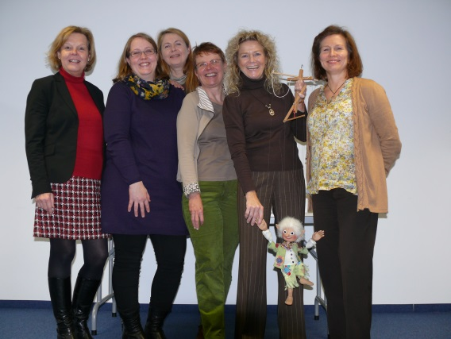
Promotors of Papilio in Finland (left-to-right): Heidrun Mayer, Chairwoman of the Board of Papilio e.V., Merja Koivula, Marita Neitola, Papilio trainer Heidi Scheer, Iiris Björnberg, and Ursula Nystedt-Rintakumpu.

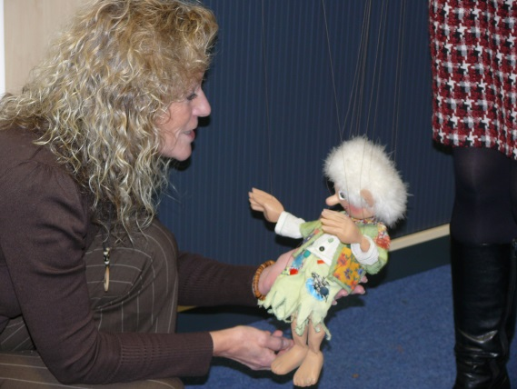
Iiris Björnberg captivated by Happybold and Papilio’s other “Pixies in the Box”.

About Papilio:
The social enterprise Papilio e.V. offers a programme aimed at the early prevention of addictive and violent behaviour. Specifically developed for young children, the programme has been well received in many countries and its effectiveness has been scientifically proven. It includes kindergarten teachers, children, and parents. Children playfully learn social rules as well as how to interact with each other and resolve conflicts non-violently. All in all, Papilio reduces early behavioural problems, encourages socio-emotional competency, and provides children with the necessary skills that will make them less susceptible to the development of addictive and violent behaviour in later life. In Germany, Papilio has been introduced in 12 federal states and more than 6,000 educational professionals – reaching more than 123,000 children nationwide – have been trained in the programme. For further information visit: www.papilio.de

Further information:
Papilio e.V.
Annika Jungclaus, Tel. +49 (0)821 4480 3297, E-mail: annika.jungclaus@papilio.de
Andrea Finkel, Tel. +49 (0)821 24 26 302-23, E-mail: medien@papilio.de
Press and Public Relations: www.papilio.de

Papilio e.V.
www.papilio.de
Chairman of the Board: Heidrun Mayer
Ulmer Str.94, 86156 Augsburg, Germany, District Court of Augsburg Register of Associations VR 200829

